**Recalling the AUTODIN – Part I**

February 24, 2012 4:36 pm 2 comments

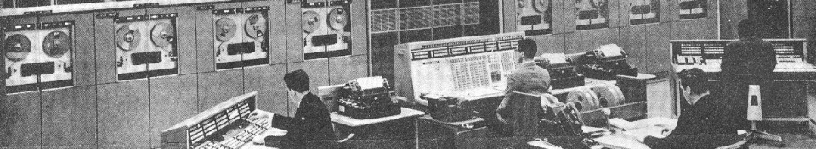

AUTODIN Control Room (Contributed by Phil Ryals)

[](http://www.computerculture.org/author/pryals/)

**DI**gital **N**etwork”) was the Department of Defense’s first computerized message switching system. It was developed to replace a semi-automatic teletype switching system called Plan 55. Like Plan 55, Autodin was developed in the late 50′s, early 60′s by Western Union. The original five Continental US (CONUS) sites were operated jointly by the military and Western Union. Subsequent sites located in other parts of the world were operated by Philco-Ford and military agencies. Autodin remained in service into the 2000′s and has been replaced by the Defense Message System.

I worked as a tech controller in the Autodin AESC (automatic electronic switching center) at Norton AFB, San Bernardino, California, from mid-1966 until 1968. The Norton switch was the first one to come on-line (around 1962, I believe) and maintained a heritage of being the most reliable switch in the system. The last full year I worked there; the switch maintained an uptime of 99.97%. That may not seem amazing, but you have to understand that this was with second-generation computers.

**Second Generation Computers**

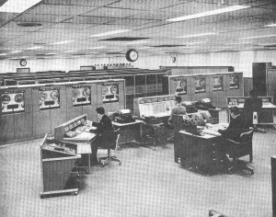

Autodin Computer Room

Autodin was initially implemented using second generation computers. These were built using semiconductors (as opposed to vacuum tubes in the first generation) but no integrated circuits. Even simple flip-flops were constructed using discrete transistors, resistors, and capacitors. Usually the circuits were built on small printed circuit boards that were plugged into racks with interconnecting wiring on the back. A large computer typically had thousands of such cards.

**Communications Data Processor (CDP)**

The primary switching computer for Autodin was called, simply, the CDP. It was a monstrous thing, comprising 19 racks of equipment, each containing hundreds of circuit cards. It was built by RCA and, if I recall correctly, was based on the RCA 501 commercial computer. It was a word-oriented (as opposed to today’s byte-oriented) machine, with 56 bits per word and ferrite core main memory storing 40,960 words. DC power requirements were quite high (hundreds of amperes) and were supplied by large motor-generator sets (AC motors driving directly connected DC generators). It needed a large air conditioner to keep it cool.

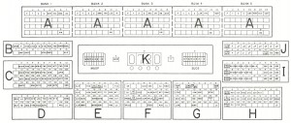

CDP Console Layout

There was a wide data bus connecting all the racks together via large cables. Because the signal path was so long, data placed on the bus was parity protected. In fact, the most frequent failure mode was a BTPE (pronounced buhTEEpee), a bus transmission parity error.

It supported a variety of I/O devices. Magnetic drum storage units holding 322 kilobytes were used to store temporary operating data. Console printing was done on Flexo-writer automatic typewriters. There was a high-speed line printer for dumps and other large printouts. A bank of half-inch reel-to-reel tape drives provided secondary storage for initial program loading, logging, and off-line message storage. It also had interfaces to multiple Accumulation and Distribution Units (ADUs – see below) and a specialized computer called the Automatic Display Processor (ADP – see below) that drove the system console.

Each switching center had two CDPs, arranged in a hot standby configuration. If the online CDP failed, all I/O devices were automatically switched to the standby processor, which took over with little discernible interruption. The CDP was notable in the history of computer development because it was microprogrammed. Each instruction in the custom language developed for the Autodin application decoded into a subroutine of simpler operations that the hardware could perform.

The message switching program on the CDP ran in a cyclic manner through receiving, switching, and sending phases. This could be observed easily on the CDP maintenance console, which provided light displays for many of the CPU registers. They were arranged to display 27-bit half words in a 3 by 9 arrangement. Each column of three binary bits could easily be read off as an octal digit, which was used for troubleshooting and debugging purposes. The rapid cyclic flashing of the register displays became very familiar to system operators and usually the first indication that anything was going wrong was a change in the light pattern as the online unit executed a transfer to the standby unit.

**Accumulation and Distribution Unit (ADU)**

ADUs were the equivalent of what would later be called communication front-end processors. They provided the interface to the data communication circuits connecting the switching center to tributary terminals and other switching centers. Each switching center had three ADUs, with two required for normal operations. The third was maintained in warm standby and could be substituted quickly for one that had failed.

**Automatic Display Processor (ADP)**

The ADP was a curious little computer used only to drive the System Console, which provided convenient display and control capabilities for operating the message switching system. It was curious in that it used mercury delay lines for main memory. That is, the contents of main memory were kept circulating in a loop through the delay lines, with the processor executing its cyclic program as the instructions streamed by. It was also curious in that its initial program load was from punched paper tape.

**Tape Search Unit (TSU)**

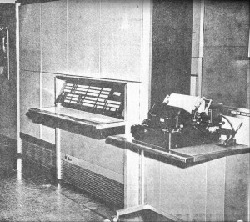

Tape Search Unit

There was also a stand-alone computer called the Tape Search Unit, which was used to search history tapes to recover messages that had failed to be delivered for some reason. This was the first computer I ever worked with that required manual entry of a bootstrap program to get it started. If the power to the TSU had been turned off you had to manually enter about thirty instructions in binary by punching buttons on the TSU front panel. That bootstrap program could then read the tape search program in from mag tape.

**Terminal Equipment**

**Synchronous Terminals**

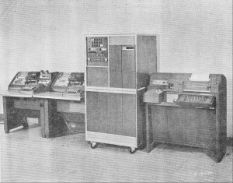

Compound Terminal

The primary terminal equipment used at Autodin tributary stations was called the Compound Terminal (CT) or, more familiarly as “the cube.” It was called that because the processor unit, made by IBM, was exactly square, about 3-1/2 feet on the sides, and about 5 feet high. It provided facilities for transmission and reception of 80-column punched cards using an automated version of the IBM 026 keypunch. It also could send and receive text messages using a Teletype ASR28, which had a paper tape punch, tape reader, and page printer. Messages were prepared by punching them into either cards or tape, then reading them into the system. The CT then transmitted them into the Autodin switch.

Larger facilities used a faster terminal built by IBM, which could punch paper tape so fast that it would fly four or five feet out of the punch before dropping to the floor. Later there was another high-speed terminal built by Univac, called the 1004/DLT6, basically a Univac 1004 computer with special data com equipment (the Data Link Terminal model 6) attached.

All the originally planned terminals operated synchronously using (originally) a six-bit character code called Field data. Later, the whole system was converted to use ASCII.

**Mode 5 Terminals**

In an attempt to reduce the cost of Autodin terminal equipment, while still obtaining its automatic acknowledgement of messages by the receiving station, the DOD commissioned Western Union to provide an asynchronous Autodin terminal that could be used with existing Baudot (five-bit code) teletype equipment. The result was an asynchronous system called Mode 5 (the main synchronous terminals were Mode 2).

A Mode 5 control unit could be connected to an existing teletypewriter terminal to provide automatic numbering of outgoing messages, and automatic acknowledgement of incoming messages. With no control characters available in the Baudot code, it transferred control sequences in a novel way–one that was later used with the Smartcom modem control codes to switch from data mode to command mode–the use of idle blind periods. A control sequence consisted of a pair of identical characters that followed an extended idle period on the line. The control unit inserted pauses in transmission so it could send acknowledgements back for received messages, and it automatically detected pauses and control sequences sent by the Autodin switch.

Mode 5 transmissions were not error protected, but there was at least assurance of delivery of each message by the automatic numbering and acknowledgement system.

[](http://www.computerculture.org/author/pryals/)

**Recalling the AUTODIN – Part II**

March 2, 2012 2:36 pm 1 comment

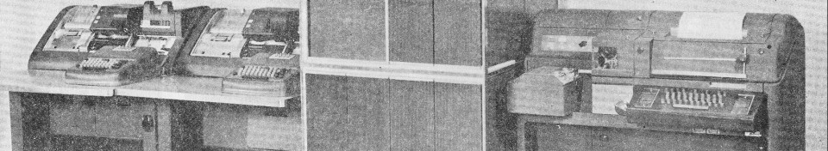

**Contributed by Phil Ryals**

We now continue our series on the AUTOmatic DIgital Network. (See Part I here)

**The Message Switching Business**

The main job at hand for the Autodin was, of course, the automatic routing of messages. Messages could be entered into the system with four or five different precedence (priorities), each of which had a performance standard that had to be met or there was a lot of explanatory paperwork to be filled out. The highest was Flash. A Flash message had to be delivered to its destination station (a terminal or trunked to another switch) within two minutes from the time it arrived.

Messages could also be entered with a security classification of Unclassified, Confidential, Secret, or Top Secret. One of the switch’s duties was to make certain that a message could not be sent over a communication circuit whose classification was lower than that of the message.

**Logging**

The switch automatically stored a copy of each message it received on a history tape (it actually wrote a copy to each of two tapes), along with timestamps of when messages arrived and were delivered. These tapes were used for offline searches to recover messages for which a “service message” was received, indicating non-delivery. There was a large tape vault where these tapes were stored for a period of time before being erased and reused, much in the same way today’s system backup tapes are managed.

**System Console**

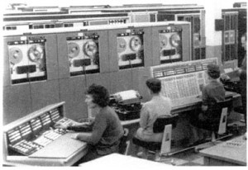

System Console

Primary control of the message switching system was done at the System Console. It had a variety of alert indicators and a numeric display that identified which circuit had an error condition. The most common problem was “no idles.” The synchronous terminals sent an idle pattern when no traffic was flowing, to maintain connectivity. When a circuit lost its idle pattern the System Console would ding quietly and the No Idles light would flash. Pressing the button over the light would display the circuit number, which the console operator would report via a push-to-talk intercom to tech control, where we would investigate the cause.

**Joint Operations Team**

Autodin switching centers were operated by a team made up of military personnel, Western Union personnel, and civilian government employees. Despite the real possibility of friction among the various factions, the Norton switching center had the highest “esprit de corp” of any place I have worked, ever. It was not at all unusual for someone who happened to be in the neighborhood to stop by on a day off, just to see how things were going. I suspect a lot of this had to do with the Norton AESC’s being the best performing switch in the system. Everybody wanted to keep it that way.

Operations personnel were a mix of civilian government employees and military personnel. Western Union provided hardware support for the computers and communications lines that connected the center to its tributaries and other switches.

**Missing Persons**

One of the biggest mysteries to me concerning operations was where everybody hung out. You could go out on the traffic floor at 2 o’clock in the morning and you’d see maybe two people: someone at the System Console, and maybe a tape search or compound terminal operator. Yet, seemingly seconds after a quietly frantic announcement over the PA system, “Western Union supervisor; we’re down,” there would be twenty people milling around waiting to see what they could do to solve whatever problem had brought the switch to its knees. I never did figure out where they materialized from.

**Short-timers**

This period (mid 1960’s) was in the Vietnam build up and the Air Force was rotating communications officers through our facility at an alarming rate. Operations shift supervisors were frequently Second- or First-Lieutenants who stayed for a few months before being transferred on to some other location. Sometimes this led to interesting situations.

On one such occasion a Flash precedence message got queued for the Army message switching station in Davis, California. We had five teletype (Mode V) circuits to Davis, but one of them was out of service. Guess which one the message got queued to?

The operations supervisor for that shift was this very excitable young lieutenant who came storming back into the tech control facility (more on that in Part 3) screaming at me, saying do this or do that. After determining what the situation was, I calmly told him “I have worked in this facility longer than you have been in the Air Force. Go back to your systems console and let me do my job.”

That, of course, increased his agitation even more markedly, and I swear he flew about a foot up off the floor. He subsequently complained to the OIC (officer in charge) of tech control that I was insubordinate and needed to be punished for it. My OIC shrugged it off and told him that he shouldn’t have been back there bothering me. We now conclude our series on the AUTOmatic DIgital Network. (See Part I and Part II)

**Recalling the AUTODIN – Part III**

March 6, 2012 11:14 pm 0 comments



**Contributed by Phil Ryals**

**Tech Control**

While the folks out on the computer floor were concerned with message switching operations, we in the technical control center were concerned with the data circuits that connected the switch to its tributary stations and other switching centers.

Autodin circuit facilities were built using the RED/BLACK concept, in which unencrypted data lines (the RED side) were kept physically separated from the encrypted circuits (the BLACK side). A typical data circuit was connected from the Accumulation and Distribution Unit to the RED side patch panel in tech control. From there the circuit went to the crypto center where it connected to a crypto machine. The encrypted output then came back to tech control where it was connected to the BLACK side patch panel, then on to a modem for transmission over an audio circuit.

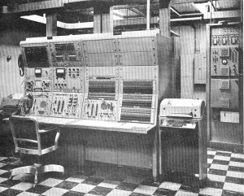

Tech Control Console

Circuit access for troubleshooting purposes was made very convenient by banks of relays in the RED and BLACK patch panels. When the System Console operator reported a problem with a circuit (usually “no idles”) they reported it using the tech control jack number; that is, the number of the patch panel jack it appeared on. A tech controller merely had to punch the jack number into the tech control console to pull the circuit up for testing. You could view either the RED side signal or the BLACK side signal on an oscilloscope, and view the flow of control characters (on the RED side) using an integral character reader. If it was a teletype circuit, you could direct it to a teleprinter for monitoring, if required.

The synchronous crypto devices could be reset if they lost synchronization by pressing a button on the tech control console. This was the usual response to a loss of idle patterns. If a crypto unit failed, it could be replaced by plugging a patch cord into the RED patch panel to shunt the signal off to a crypto spare, plus a corresponding patch on the BLACK patch panel to connect the spare crypto unit back to the original modem.

**Facility Ratings**

Each tech control shift (24/7) had to have at least one person on staff who was technically qualified (demonstrated through a series of tests) to direct the telecom operations. Such a person was said to be “facility rated.” Again because of the Vietnam build up, communications personnel were being rotated on a frequent basis, so there was always a shortage of facility rated individuals to assign. Coming in with a computer background, I achieved full facility rating fairly quickly, which saved me from several hideous reassignments because of the lack of qualified personnel.

This led to a quirky work-around with dual shift supervisors. The individual with the highest rank was denoted the “military” supervisor for the shift, but if he (there were no female tech controllers in those days) wasn’t facility rated, another airman with a facility rating was denoted the “technical” shift supervisor and his word was binding when it came to determining what should be done to effect recovery of a failure.

I remember the confusion on the other end of the telephone when a controller at another facility, who had been speaking to sergeant such and so, asked for the shift supervisor and I answered, “Airman Ryals.” He said, “No, I wanted the shift supervisor.” I replied, “You’ve got him. What do you need?”

**Training Tribulations**

Because I had been facility rated for a while and generally understood the system, I was assigned to be the unit training supervisor. This didn’t sit too well with some of the troops who greatly out ranked me who were relegated to shift work while I got the cushy day job. My main task assignment was to rewrite the tech control training manual.

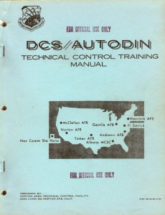

AUTODIN Training Manual

The two manuals used previously at Norton tech control were essentially just reprints of Western Union system documentation. They did a good job of explaining the various facets of the system, but they didn’t really tell you how to troubleshoot a failure and recover from it. I know many of the older controllers would have preferred to have a decision tree that they could follow, but there was insufficient time to develop one that would have been comprehensive. Instead, I opted for clear language explanations of how the parts worked, and hoped that coupling understanding of the system with controllers’ training and experience in trouble isolation would lead to a good result.

Long before word processing software was thought of, I was producing camera-ready pages for the manual by typing them on an electric typewriter. Neither of the two error-correcting methods I had available (white-out, and correction tape) produced a result that was clean enough for reproduction, so I had to type each page perfectly. One day my wife, who worked at the same facility (she was a WAF and operated the compound terminal), came by when I was away from my typewriter, and decided to “help” me by finishing the page that I had mostly completed. Instead, she wound up with a typo in the last line and I had to start the page all over. Thanks, dear.

**Western Union**

Modems and communication lines for Autodin were provided by Western Union, which had a direct connection to their national microwave radio system for the long-haul circuits. They also had a fat cable to the local telephone company for use if their microwave system failed for any extended period of time. Whenever a tech controller determined that the problem was with a circuit, he handed it off to Western Union personnel for resolution.

**Bomb Alarm**

Western Union also had other government data circuits passing through their facilities, the most interesting of which was the bomb alarm. This was in the late 60′s, during the height of the Cold War, and NORAD had an elaborate matrix of low-speed data circuits connected to transponders mounted on telephone poles in various cities around the country. These transponders were polled every few minutes to see if they were still there.

Because the location of the transponders and the route of the circuits were known, a computer at NORAD headquarters could figure out from which signals were missing what cities had been bombed in a nuclear attack. Pretty scary thought, isn’t it. We were aware of the bomb alarms because a bank of signal relays near our tech control console chattered in a distinctive pattern each time the transponders were polled. I am pleased to report that the bomb alarm system never saw any real use.

**Forest Fire**

Probably my most exciting time in tech control was related to a forest fire that burned through the microwave repeater connecting our site to the Western Union system. The heat was so intense that it melted antennas and waveguides off the tower.

I was working the tech control coordination position and as a result of the Norton site being essentially cut off from the rest of the world circuit-wise, I had to send out bunches of failure report messages and call all over the place. I had never before in my short military career had the occasion to speak with so many colonels and generals. Our switch served SAC bases, so Strategic Air Command headquarters was most interested in tracking our outage and attempts to recover from it. Likewise, for the Tactical Air Command and a bunch of other headquarters.

Western Union personnel ordered up a boat load of circuits from the telephone company and restored as many connections as they could. Sometime in the middle of the night a Western Union microwave installation team miraculously managed to hang large microwave dishes on a 50-foot tower, while being buffeted by 60 mph winds flowing across the ridge and into the base of the fire. Twenty-four hours later all was back to normal.